ER DIAGRAM OF SYSTEM

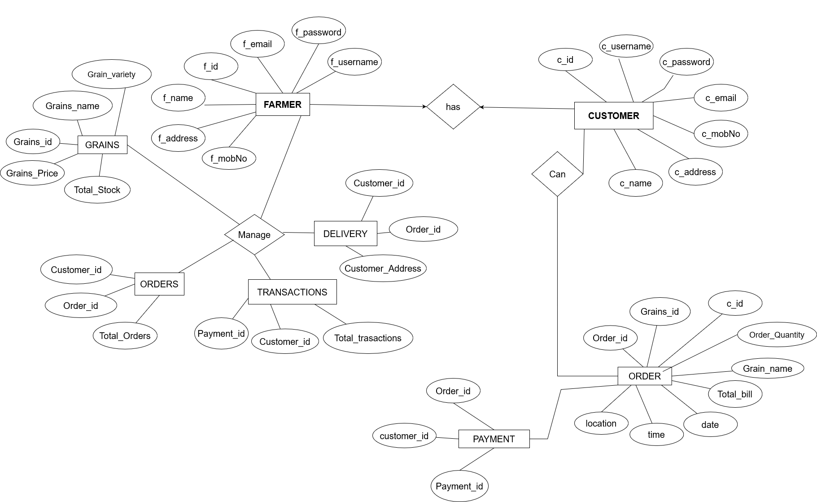

SEQUENCE DIAGRAM OF CUSTOMER

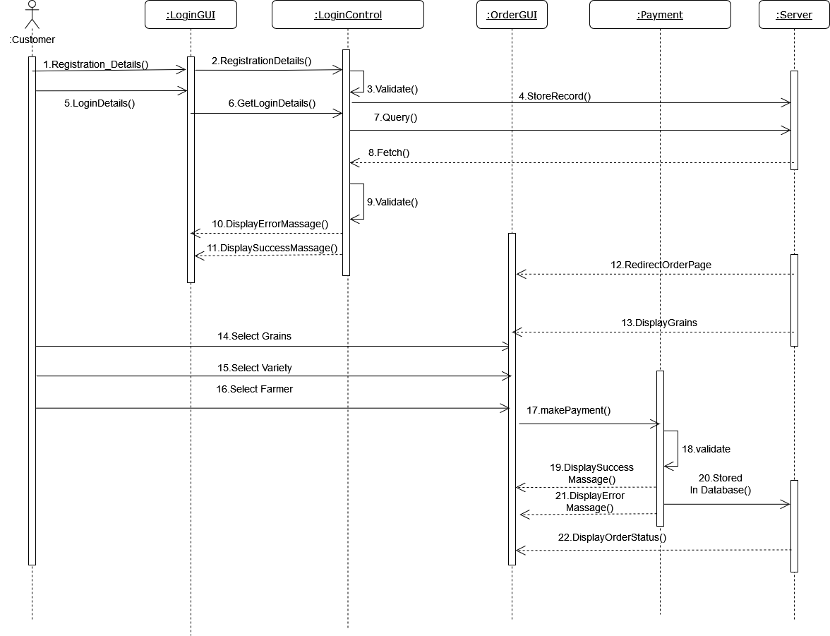

SEQUENCE DIAGRAM OF FARMER

